Design and Technology Policy

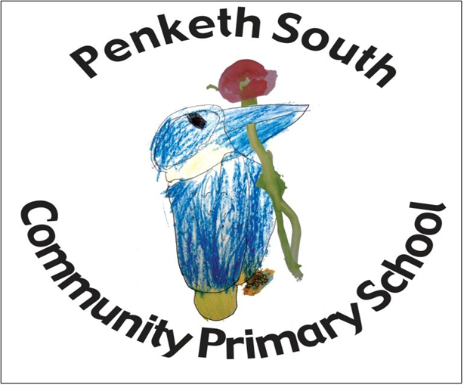
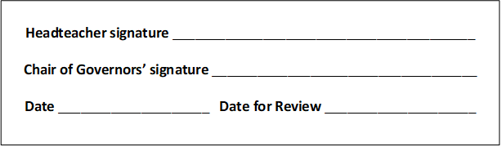

“The importance of Design and Technology

‘Design and Technology is an inspiring, rigorous and practical subject. Using creativity and imagination, pupils design and make products that solve real and relevant problems within a variety of contexts, considering their own and others’ needs, wants and values. They acquire a broad range of subject knowledge and draw on disciplines such as mathematics, science, engineering, computing and art. Pupils learn how to take risks, becoming resourceful, innovative, enterprising and capable citizens. Through the evaluation of past and present design and technology, they develop a critical understanding of its impact on daily life and the wider world. High quality design and technology education makes an essential contribution to the creativity, culture, wealth and well-being of the nation.’
The 2014 Primary National Curriculum in England, Design and technology, page 180

Intent
At Penketh South the teaching of Design Technology follows the National Curriculum through the use of the Design and Technology Associations Projects on a Page.
Through a variety of creative and practical activities, we teach the knowledge, understanding and skills needed to engage in an iterative process of design and making. Children are given projects which have a purpose in mind and an intended user for the product. Food Technology is implemented across the school with children developing an understanding of where food comes from, seasonality of ingredients, and the importance of planning and preparing a healthy varied diet.

Implementation
Aims and Purposes

The national curriculum for design and technology (DT) aims to ensure that all pupils:
- develop the creative, technical and practical expertise needed to perform everyday tasks confidently and to participate successfully in an increasingly technological world.
- think and talk about how things work, and to draw and model their ideas.
- build and apply a repertoire of knowledge, understanding and skills in order to design and make high-quality prototypes and products for a wide range of users.
- critique, evaluate and test their ideas and products and the work of others.
- understand and apply the principles of nutrition and learn how to cook.

Expectations

By the end of each key stage, pupils are expected to know, apply and understand the matters, skills and processes specified in the relevant programme of study. (The 2014 Primary National Curriculum in England, Design and technology, page 180)

Organisation and Planning

At Penketh South, the teaching of Design Technology follows the National Curriculum through the use of the Design and Technology Associations Projects on a Page.
Through a variety of creative and practical activities, we teach the knowledge, understanding and skills needed to engage in an iterative process of design and making. Children are given projects which have a purpose in mind and an intended user for the product. Food Technology is implemented across the school with children developing an understanding of where food comes from, seasonality of ingredients, and the importance of planning and preparing a healthy varied diet.

EYFS
Within our Nursery and Reception classes our children explore and use a variety of media and materials through a combination of child-initiated activities and play, and adult directed activities. They express their own ideas using a variety of media and materials, they plan and construct with a purpose in mind. They will develop their skills in using simple tools and techniques safely.

KS1
Within KS1 children will design, make and evaluate using a range of relevant contexts. They will be taught the knowledge and skills needed to engage in an iterative process of designing and making.

KS2
Within KS2 children will build upon the knowledge and skills taught in KS1. They will be expected to produce more detailed planning and annotated sketches. They will investigate and analyse existing products, and within KS2 there is more emphasis on looking at events and designers who have influenced the world of Design Technology.
Within KS2 children should be introduced to computer programmes and applications which will help in the design of products.
They will build on their understanding of a healthy and varied diet, looking at seasonality and different cooking techniques.

Across school, all children build upon prior learning to give a progression through year groups. They are given the opportunity to work as a class, as part of a group or as an individual. The choice of class organisation will be determined by; the learning task or activity, the nature of the theme and the resources being used.

Linking with other subjects

English
Design and technology contributes to the teaching of English by providing valuable opportunities to reinforce prior learning. Discussion, drama and role-play are important ways for the children to develop an understanding that people have different views about design and technology. The evaluation of products requires children to articulate their ideas and to compare and contrast their views with those of other people. This also promotes our school’s questioning focus to develop their deeper thinking skills. Through discussion, children learn to justify their own views and clarify their design ideas.

Maths

In design and technology, children learn to measure and use equipment correctly, generate nets of shapes in order to create packaging and weigh and measure accurately. They will also learn about size and shape and make “real” use of their mathematical knowledge in order to be creative and practical in their designs and modelling. They will also develop their problem-solving skills and the various element of design technology require logical and systematic thinking and approaches.

Science

Science helps in design and technology, by looking at, making and drawing electrical circuits. It also helps children to think about using materials to create structures which can withstand a force. Design Technology also reiterates aspects of material changes and fabrics that would be suitable to combine based on their properties.

Computing

Computing enhances the teaching of design and technology, wherever appropriate, in all key stages. Children may use software to enhance their skills in designing and making things. Younger children are able to use simple software to enhance their learning. Older children use programs to control mechanisms and to produce computer-aided designs. The children also use computers to collect information about existing products and to present their designs through a range of design and presentation software.

Personal, Social and Emotional Education (PSHE)

Design and technology contributes to the teaching of PSHE by encouraging children to develop a sense of responsibility in following safe procedures when making things. They also learn about health and healthy diets. Their work encourages them to set targets and meet deadlines. They will also learn how to prevent disease from spreading and about personal hygiene when working with food.

Nutrition and Cooking

Children will be taught how to cook and apply the principles of healthy eating and nutrition. Learning how to cook is an essential life skill that will enable children to look after themselves and others now and in later life.

Assessment, Recording and Reporting

Each child’s performance in Design Technology will be assessed by the teacher against the learning objectives for the lessons. Children are also encouraged to reflect on their work and suggest ways in which it can be improved. These assessments will then be used to judge pupils progress against end of year expectations for their year group. Pupil progress will be reported to parents in writing through termly parent evenings and end of year reports.
Evidence of children’s work will be collected by the subject leader to help demonstrate the level of achievement within each year group across the school. e promote resilient, problem solving learners who are very articulate and can talk through problems. These skills are at the heart of our design curriculum and children use them to really explore and become passionate, curious and experimental in design.

Inclusion and Differentiation

In every class within school there are children of differing abilities. In order to provide all pupils with relevant and appropriate work at each stage:
- We set suitable learning challenges
- Respond to pupils’ diverse needs
- Endeavour to overcome potential barriers to learning

The Role of the Subject Leader

- To advise colleagues, where necessary, on the development of planning and delivering the curriculum.
- To keep up to date with developments in design and technology education passing this on to other members of staff.
- To monitor and evaluate progress in design and technology to liaise with senior management on any action necessary.
- To liaise with appropriate bodies e.g. other TCAT schools, governors, the LEA etc. concerning matters relating to design and technology.
- To monitor the quality of teaching and learning in design and technology by working alongside colleagues and by viewing children's achievements.
- To keep a portfolio of evidence of children’s achievements as well as evidence of pupil voice from across the school.

Resources

The location and storage of many consumable items can be found in the Resources room and class teachers replace their stock/order new requirements as needed.
Some tools (e.g. hammers, clamps, junior hack saws) and non-consumable items can be found at Forest school in the cabin. Food preparation and cooking equipment is to be found in the library area in Key Stage 2.

Health and safety

Health and safety is important, particularly when working with tools, equipment and resources. Children should be given suitable instruction on the operation of all equipment before being allowed to work with it. Children need to be taught:

- about hazards, risks and risk control
- to use the information to assess the immediate and cumulative risks
- to explain the steps they take to control risks.
- use tools and equipment correctly
- to manage the environment to ensure the health and safety of themselves and others
- be strictly supervised in their use of equipment at all times
- be taught to respect the equipment they are using and to keep it stored safely while not in use
- be taught to respect the equipment they are using and to keep it stored safely while not in use

Food Hygiene
- How to follow proper procedures for food safety and hygiene.
- Pupils and staff will take care to undertake appropriate hand washing and other hygiene related activities prior to preparing food.
- Pupils and staff working with food must wear aprons designated for cooking.
- All jewellery should be removed and hair tied back
Sawing
- • Bench hooks and clamps must be used when sawing any material.
- • Safety goggles must be worn and any loose items of clothing/hair must be tucked in.

Risk assessments are carried out by the class teacher for activities where a risk assessment is deemed appropriate. All school visits are carefully planned with safety in mind and consideration of the age and ability of the children. Field trips are well supervised. Staff should refer to the Educational Visits Guidelines. All trips require a risk assessment.

Impact
Our DT curriculum enables and encourages children to become critical thinkers. They look at existing designs to analyse and assess their effectiveness, then consider ways of redesigning and reconstructing to meet their own requirements. To this end, our children learn to become resourceful, innovative and enterprising individuals who are passionate and excited about the design and making process. Progress in Design and Technology is demonstrated through regularly reviewing and monitoring of children’s work, in accordance with the school's assessment policy to ensure that progression of skills is taking place. Namely through:
Looking at pupils’ work, especially over time as they gain skills and knowledge
Observing how they perform in lessons or during a learning walk.
Talking to them about what they know.

The DT curriculum will contribute to children’s personal development in creativity, independence, judgement and self-reflection. This would be seen in them being able to talk confidently about their work, and sharing their work with others.
We will be able to find evidence that our children enjoy and value DT and know why they are doing things, not just how.
Children will be able to understand and appreciate the value of DT in the context of their personal wellbeing and the creative and cultural industries and their many career opportunities.
Progress will be shown through outcomes and through the important record of the process leading to them.

Reviewed October 2023
Janou Birchall

