Penketh South CP School

Remote Learning Policy
Version | Date | Action
V1 | September 20 | New Policy
 | November 2020 | Approved by FGB
 | September 2021 | Reviewed

Curriculum Intent Statement
Do your best. Be your best.
On the children’s journey through Penketh South we aim to spark their curiosity and fire their enthusiasm. We want our children to take pride in themselves, their achievements and their environment. They will be taught to respectfully question, to show appreciation for the world around them and to accept and understand equality and diversity. We will provide opportunities for our children to develop as independent, confident and successful learners who have high aspirations for the future. The children will be encouraged and supported to become resilient learners who understand that it is ok to make mistakes as long as they use these experiences to help them to develop and grow. Our children will become learners for life, powerful contributors, confident individuals and responsible citizens of the future.
Aim of Policy
At Penketh South, we aim to ensure that our curriculum continues to adhere to our Curriculum Intent Statement, including in the event of pupils working remotely due to a lockdown situation or a period of isolation.
Through the implementation of this policy, we aim to address the protocols and procedures we will need to follow as well as address the key concerns associated with remote working, such as online safety, access to educational resources, data protection and safeguarding.

General principles
- The staff at Penketh South will remain available to support pupils and parents both pastorally and academically during periods of lockdown or isolation. Any concerns should be communicated within the school working day as soon as possible so that any issues can be addressed swiftly.
- The welfare of the pupils, parents and staff is paramount and expectations have therefore been laid out clearly to try to protect all members of the community.
- There is an expectation that during lockdown or isolation, all pupils who are well will engage with remote learning and attendance will continue to be monitored through the normal school Attendance Policy and so parents should report absence in the normal way by contacting school by 9 a.m. of the first missed day.
- Google Classroom will continue to be the online platform which we use in periods of lockdown or isolation.
- Suggested timetables will be provided and children will be expected to work within the hours of 9 a.m. and 3 p.m. with appropriate breaks built in to the ‘school day’
- We aim to be consistent in our approach to home learning but there will need to be a degree of flexibility in order to meet the needs of different ages of pupils and the different circumstances that may occur. Please see below.

Specific responsibilities
Governors
- Ensuring that appropriate risk management procedures are in place
- Ensuring that the school has a business continuity plan in place
- Evaluating the effectiveness of the school’s remote learning arrangements
Headteacher / Deputy Headteacher
- Ensuring that staff, parents and pupils adhere to the relevant policies at all times
- Ensuring that there are arrangements in place for monitoring incidents associated with remote learning
- Ensuring that the staff are equipped with the appropriate resources and training in order to action the expectations laid out in this policy
- Reviewing the effectiveness of this policy on a regular basis and communicating any changes to staff, pupils and parents
- Supporting staff to review the quality of pupil learning and engagement
Senior Leadership Team
- Supporting staff in delivering home learning
- Supporting Head and Deputy Headteacher in identifying any specific issues with pupils, resources, quality of learning, etc.
- Supporting Head and Deputy Headteacher to provide home learning in the event that a class teacher is absent, ill or supporting family members (as per Authorised Leave Policy)
SENDCo
- Ensuring that pupils with Education and Health Care Plans continue to have their needs met whilst learning remotely
- Liaising with appropriate agencies and individuals in order to ensure that provision meets the needs of pupils
- Supporting staff to identify the level of support or intervention that is required whilst pupils with SEND learn remotely
- Monitoring the quality of provision, engagement and learning for pupils with SEND
IT Lead
- Supporting staff in developing own practice in relation to remote learning
- Providing or signposting technical support and/or working with the TCAT IT team where appropriate
- Supporting the SLT in providing equipment (with appropriate anti-virus software) for specific families
Class teachers
- Adhering to this policy at all times during periods of remote learning
- Providing work in line with National Curriculum guidelines that adheres to the principles of our curriculum intent
- Being mindful of their own well-being and the well-being of pupils and their families
- Reporting any safeguarding or health and safety concerns to the DSL and asking for guidance where appropriate
- Continuing to develop own practice in order that remote learning is of the highest quality, e.g. through training, advice from colleagues, instruction from the SLT
- Adhering to the Staff Code of Conduct at all times
- Adhering to online safety procedures as detailed below
Teaching assistants
- Adhering to this policy at all times during periods of remote learning
- Supporting teachers in the provision of remote learning by, for example:-
  - Releasing teacher for short sessions in order that they provide or support online learning
  - Providing / uploading activities onto Google Classroom as directed by class teacher
  - Supporting teacher in live or recorded sessions
  - Contributing to Google Classroom ‘stream’
- Being mindful of their own well-being and the well-being of pupils and their families
- Reporting any safeguarding or health and safety concerns to the DSL and asking for guidance where appropriate
- Adhering to the Staff Code of Conduct at all times
- Adhere to online safety procedures as detailed below
Parents
- Adhering to this policy at all times during periods of remote learning
- Adhering to Government guidelines in relation to isolating
- Ensuring their child follows the suggested timetables and programmes of work
- Supporting their child where needed – both emotionally and academically
- Reporting any absence in line with the terms set out in this policy
- Ensuring that any equipment loaned from school is used appropriately
- Monitoring the Google Classroom Feed at least daily
- Communicating any difficulties or concerns as soon as possible to the class teacher or the school office
- Celebrating their child’s successes and communicating to school where appropriate
- Supporting their child in adhering to online safety procedures as detailed below

Online Safety (in conjunction with School Online Safety Policy)
- When conducting pre-recorded or live sessions, staff must ensure that:-
  - they communicate in groups: one-to-one sessions are not permitted except in exceptional circumstances (to be endorsed by Headteacher / Deputy Headteacher)
  - there are at least two staff members ‘present’ at all times
  - they wear suitable clothing (and ensure that when working in the home environment that all members of the household also wear suitable clothing)
  - they conduct the live session in a suitable location (e.g. not in a bedroom)
  - they maintain the standard of professional behaviour expected in school
  - permission is sought prior to recording, storing or distributing any video material
  - they endeavour to ensure a stable wifi connection in a quiet environment in order to avoid disruption
  - they ensure the behaviour of pupils is appropriate – any serious or persistent inappropriate behaviour should be communicated to parents and/or the SLT
  - any loaned equipment provided by the school has anti-virus software installed, can establish secure connections and allows for audio and visual material to be accessed when required. The school is not responsible for providing online safety software on equipment not owned by the school.
  - all links posted on Google Classroom are safe and secure
  - they direct parents and children to appropriate safeguarding resources around keeping safe online
- When participating in live sessions, parents must ensure that:-
  - everyone within the household wears suitable clothing
  - the session takes place in a suitable location, e.g. not in a bedroom
  - an adult is in the vicinity
  - appropriate language is used and high standards of behaviour are maintained
  - video material is not recorded, stored or distributed without permission
  - their child exhibits a positive attitude towards learning sessions and is not distracted by items such as mobile phones, other electronic devices, etc.

Key Stage 1 and 2 Remote / Home Learning expectations

Scenario | School responsibility |  | Child / parent responsibility
- Individual pupil illness | No remote learning |  | Child be supported to recover from illness  Inform school no later than 9:00 a.m.
- Individual pupil isolating due to having COVID symptoms until outcome of test. | No remote learning |  | Child be supported to recover from COVID symptoms  Inform school as soon as possible but no later than 9:00 a.m. of the first missed day if the child has become symptomatic at home  Follow government guidance in relation to isolating
- Individual pupil or small number of pupils isolating (2 days or more) due to family member having symptoms but well and class teacher well but teaching in school | Minimum requirement | In specific circumstances… | In first two days (or up until work is set by school), support child by practising basic skills such as reading, maths games, etc.  Follow government guidance in relation to isolating  Ensure child logs on to Google classroom daily and completes set tasks according to the suggested timetable between the hours of 9 a.m. and 3 p.m.  Support child to ensure they understand teacher expectations  Encourage, praise and support child as appropriate  Contact class teacher or office if any concerns, queries or technical difficulties  Contact office if struggling to access work due to lack of internet provision or shortage of devices within the family home  If family circumstances prevent an adult from supporting a child (e.g. due to illness), allowances may be made.
 | - Class Teacher provides work by end of 2nd day isolation at the latest  - Teaching assistant supports class teacher, e.g. by providing specific activity where appropriate; releasing class teacher for short periods of time to provide work / monitor, etc.;  - Suggested timetable to be provided for parents / children including suggestion of time to be spent on each activity  - Weekly plan of suggested Maths and English activities (e.g. signposting to appropriate Oak Academy resources)  - Provide knowledge organiser for Science / foundation subject(s)  - Include activities that are away from technology  - Monitor daily attendance and report to school office  - At least twice weekly ‘check-in’ via Google Classroom | - Daily plan directly linked to work the rest of the class is working on (including live or recorded short sessions in some cases)  - More regular contact – e.g. a phonecall, particularly in relation to poor attendance / engagement  - Respond to an email from a parent or child (between 9 a.m. and 4 p.m.)  - Support family with internet or device provision where possible  - Paper pack of work to be made available
- Individual pupil isolating due to family member having symptoms but well but class teacher unwell | SLT to liaise with appropriate bubble staff in order to achieve the above (scenario 3) |  | As scenario 3
- Whole class isolating due to positive COVID test(s) and class teacher well | Minimum requirement | In specific circumstances… | Follow government guidance in relation to isolating  Ensure child logs on to Google classroom daily and completes set tasks according to the suggested timetable between the hours of 9 a.m. and 3 p.m.  Support child to ensure they understand teacher expectations  Encourage, praise and support child as appropriate  Contact class teacher or office if any concerns, queries or technical difficulties  Contact office if struggling to access work due to lack of internet provision or shortage of devices within the family home
 | - English and Maths activities set daily (available to parents / children by 9 a.m.) – can use Oak Academy, White Rose, etc.  - Daily ‘register’ to be taken at 9 a.m. and non-attendance to be reported to school office by 9:30  - Daily check in on Google Classroom (by 4 p.m.)  - General feedback to whole class or individual feedback if class teacher feels this is warranted  - Knowledge organiser for Science or Topic used to set work for the week  - Include activities that are away from technology  - Teacher or TA to contact individual parents when there is little or no engagement with remote learning | - Live or recorded short sessions used to enhance support for pupils  - Member of SLT contacts parents or carers when there is little or no engagement  - Support family with internet or device provision where possible  - Paper pack of work to be made available
- Whole class isolating due to positive COVID test(s) but class teacher unwell | SLT to liaise with appropriate bubble staff in order to achieve the above as scenario 3. |  | As scenario 3

Example of EYFS learning plan
Nursery Home Learning 1
 | Day 1 | Day 2 | Day 3 | Day 4 | Day 5
Get ready for the day | Choose one item of clothing to focus on this week. Build up your skills each day until you can hopefully do it yourself by the end of the week. Ideas include: pants, trousers, socks, top. Maybe even buttons, zips, buckles or laces!
Wake up shake up | Lets get moving guys and do some boogie beebies on Youtube for easy to follow instructions  https://www.youtube.com/results?search_query=boogie+beebies
Physical | Scissor skills (please see the EYFS Home Work sheet. Please choose one to complete). | Pencil control: Carefully draw your favourite toy. Now colour it in. Remember to stay in the lines. | Go to the dough disco! (small amount of playdough needed. If you do not have any, please see recipe sheet to make some)  https://www.youtube.com/watch?v=3K-CQrjI0uY | Ball skills: Practise throwing a ball up into the air and catching again. How many times can you do it without dropping it? | Ask a grown up to play ‘Simon Says’  Simon says run on the spot, Simon says jump up and down. Be careful not to get caught out.
Phonics | Make some listening ears to help  you do good listening at home!  A template is available on Twinkl  or you can make your own using any  available resources and design you like!  https://www.twinkl.co.uk/resource/t-l-1319-good-listening-ear-head-bands | Go into the garden with your listening ears and listen carefully to the sounds you can hear. Some sounds will be loud and some you might need to listen more carefully for. Ask a grown up to help you make a list using drawings. | Wear your listening ears to play  a listening game.  https://www.youtube.com/watch?v=h0Kp_J9kvNM | Wear your listening ears whilst looking around your home. Can you find things that make sounds around the house? Washing machines, taps, creaky floorboards and hinges, toilet flushes, clocks. Again, make a list using drawings. | Make a collection of noisy objects from around the home! You could sort them into different groups, e.g. loud noises and quiet noises.
Maths | Can you practice counting to 10?  Here is a little song to help you  https://www.youtube.com/watch?v=TjmGTbNLj6Q | Can you count the correct number of objects? Use cake cases with numbers written in or number cards if you have them. Can you count out the correct number of cars/lego pieces/cereal hoops to match? | Can you make the caterpillars bodies? Use finger paint or coloured pencils to give them the correct amount. (See fingerprint caterpillars sheet)  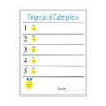 | Can you go on a number hunt around the house? Can you spot numbers up to 5?  • You could look in books and magazines, on door numbers, number plates, clocks, price labels, remote controls, phones, calendars or greetings cards. • Encourage your child to talk about the numbers they see and record their findings by drawing pictures or taking photos of the numbers they find. | Can you match the numbers 1-5 ( See number matching activity 1-5)  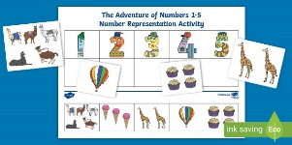
Play activity | Make a stick person or animal –  (See art activity sheet) | Lets get building – ( See Building and model sheet 1)  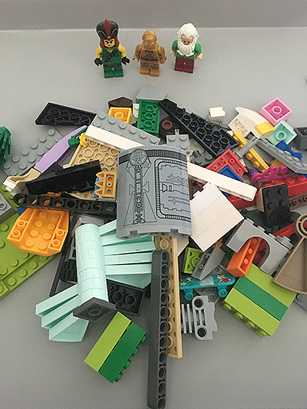 | 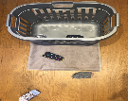  Who likes playing games? This one is a target game. See if you can beat your grown up. ( See Games sheet 1) | Make believe camping with your teddies (See make believe play 1)  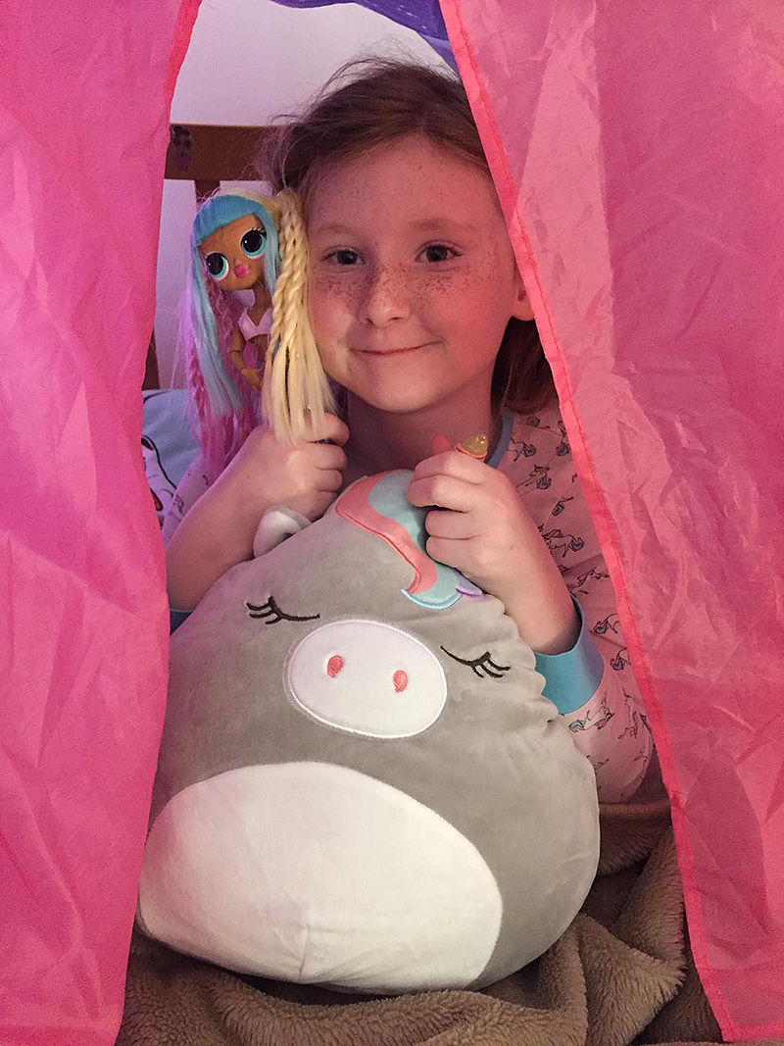 | Sensory play – Slime!  ( See sensory sheet 1)
Perhaps you could upload some of your learning to Google Classroom for us to see? We would love that.
Please note: ‘You’ refers to the child.
Phonics and Maths Activities could change depending on the point in the year.
Nursery Home Learning 2
 | Day 1 | Day 2 | Day 3 | Day 4 | Day 5
Get ready for the day | Choose one item of clothing to focus on this week. Build up your skills each day until you can hopefully do it yourself by the end of the week. Ideas include: pants, trousers, socks, top. Maybe even buttons, zips, buckles or laces!
Wake up shake up | Get your morning off to a great start with a good stretch! Watch Cosmic Kids Yoga on Youtube for easy to follow instructions. https://www.youtube.com/results?search_query=cosmic+kids+yoga
Physical | Scissor skills (please see the EYFS Home Work sheet. Please choose one to complete). | Can you use some pegs to attach them to a different object? Maybe a washing up bowl or a bucket? How many can you do? | Go to the dough disco! (small amount of playdough needed)  https://www.youtube.com/watch?v=3K-CQrjI0uY | Put your favourite song on and have a dance. If your grown up can film it we would love to see. | Can you thread some pasta onto a straw/pipe cleaner/ piece of wool? How many can you do?
Phonics | Sing Old McDonald had a farm  Can you make the sounds and remember the actions we do at Nursery?  https://www.youtube.com/watch?v=_6HzoUcx3eo | Ask a grown up or older sibling to read you a story. Together use your voices to add sound effects; maybe a ticking clock or a car engine? | Ask a grown up or older sibling to read you a story. Together use your voices to add sound effects; maybe a ticking clock or a car engine? https://www.twinkl.co.uk/resource/t-l-188-voice-sound-display-cards-phase-1 | Listen to a retelling of ‘Peace at Last’ by Jill Murphy and use your voice to add the sound effects.  https://www.youtube.com/watch?v=9U9y35kWBvM | Play an animal themed guessing game. Make some sound effects for different animal noises and ask someone to guess what animal you are!
Maths | Watch the shape song. See which ones you know.  https://www.youtube.com/watch?v=w6eTDfkvPmo | Can you make a shape picture? Ask your grown up to help with the cutting.  ( See shape pictures sheet ) | Can you go on a shape hunt around the house and garden? How many can you find?  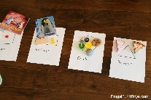 | Lets get cooking. Follow a recipe with your adult and help them with the measurements. | How tall are you? Can you find some things around the house that are the same size as you, shorter than you and taller than you?
Play activity | Lets get creative. Who can make a playdough dinosaur or Monster? (See playdough dinosaur sheet)  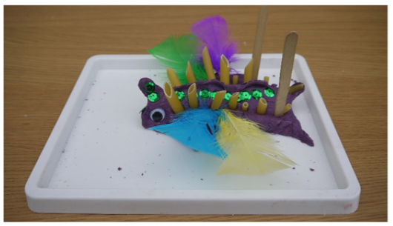 | Can you have a teddy bears tea party? Maybe you could make some invites. | Who can build a tall tower? ( See building and modelling 2)  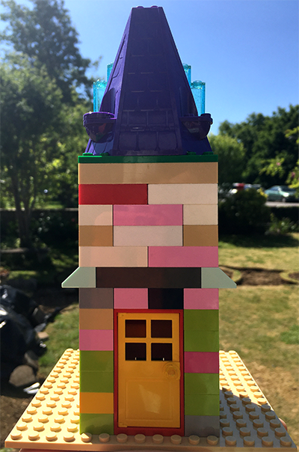 | Lets make a café ( See make believe play sheet 2 for ideas)  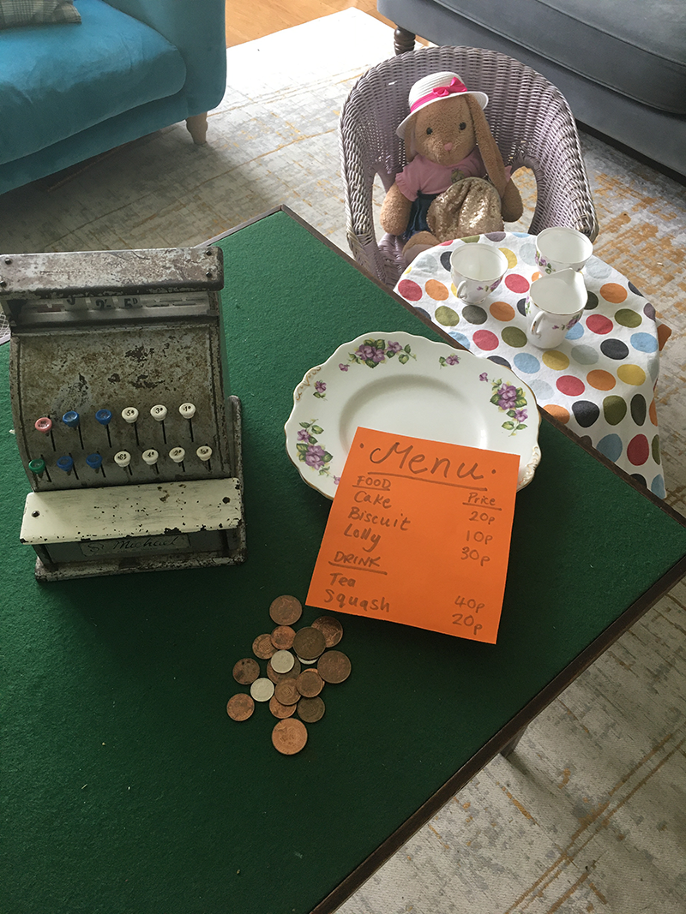 | Making bubbles  (See sensory play sheet 2)
Perhaps you could upload some of your learning to Google Classroom for us to see? We would love that.
Please note: ‘You’ refers to the child.

Phonics and Maths Activities could change depending on the point in the year.

In the event of a national or local lockdown where critical workers’ children and vulnerable children are in school and other children are working remotely
- Schools will ensure that we abide with the DfE’s expectations when setting work for pupils to work on at home. We will:-
- set assignments so that pupils have meaningful and ambitious work each day in a number of different subjects
- set work that is of equivalent length to the core teaching pupils would receive in school, and as a minimum of 3 hours a day, on average, across the school cohort
- provide frequent, clear explanations of new content, delivered by a teacher or through high-quality curriculum resources or videos
- have systems for checking, at least weekly, whether pupils are engaging with their work, and inform parents immediately where engagement is a concern
- gauge how well pupils are progressing through the curriculum using questions and other suitable tasks, and provide feedback, at least weekly, using digitally facilitated or whole-class feedback where appropriate
- enable teachers to adjust the pace or difficulty of what is being taught in response to questions or assessments, including, where necessary, revising material or simplifying explanations to ensure pupils’ understanding

- Parents will be expected to support their children with home working, although we appreciate that some parents’ circumstances may make this challenging. We will work with parents to find solutions to any difficulties.

- Parents should supervise their children in order to support their child, ensure a high standard of work, and to ensure an appropriate level of safeguarding is in place. See page 4 for further details.

- We will send home exercise books and other resources which will support home learning. These home learning packs will be made available for parents and carers to pick up from school.

- Our main method of communicating with pupils and parents will be through Google Classroom. All of the pupils have their own log-in details. Parents can also contact the class teacher via the class email address, e.g. year4@penkethsouth.co.uk

- Each class teacher will post work in Google Classroom for children to complete each day. This work will be in various formats, including use of Power Maths, worksheets, quizzes, Powerpoints, live or recorded sessions, links to websites, videos provided by Oak Academy, BBC, etc.

- Each class teacher may provide an appropriate timetable. This is for guidance only as we recognise each child’s circumstances might be very different.

- A typical day in EYFS might include:-

  - Register
  - Get ready for the day task
  - Wake up, shake up
  - A physical activity
  - A phonics activity or live or recorded phonics session
  - Live story time every day (which will be recorded)

- A typical day in Key Stage 1 might include:-

  - Register
  - 4-a-day or handwriting activity
  - Reading and/or reading comprehension task
  - English task
  - Maths task
  - Topic task
  - Regular live or recorded sessions – at least three times a week

- A typical day in Key Stage 2 might include:-

  - Register
  - Reading and/or Reading Comprehension Task
  - English Task
  - Maths Task
  - Topic Task
  - We also endeavour to have at least one recorded/live session per day. Furthermore, we will have live meetings with the class at least twice a week.

- There is registration each day. Ideally pupils will ‘register’ between 9 and 9.30 each morning but we recognise that this might be difficult for some parents to manage. Therefore, children should register when they are first able to get online.

- When work has been completed by each child, they should ‘turn it in’. They also have the option to photograph work or upload associated documents or files or with younger children, it would be lovely to see comments from parents or carers about the things the children have done.

- An adult in school may then make either groups comments on the class feed or provide individual feedback in relation to a specific piece of work. Feedback will be regular.

- When it is clear that a child is struggling with a piece of work, the class teacher or designated adult will make contact in order to provide support or work may be adapted according to need.

- A child or a parent/carer may also contact school for additional support.

- Where there is a difficulty with wifi access, school will work to support the family in obtaining data.

- In the event that a family is struggling with access to a suitable home-working device such as a laptop or chromebook, school will make every attempt to provide a suitable device.

- In the event that a child is not interacting with home learning, a member of staff will make contact to ascertain whether there are any difficulties. We will make every attempt to support the family so that every child can engage in the home learning activities.

- When there are particular concerns, a member of SLT may make contact to discuss the importance of home learning and again, offer support.

- In rare circumstances, we may encourage parents to send their child into school, particularly if there are SEND concerns.

